**Date:** 8 Feb 2017

**Reg. No.:** 14BIT004

**Experiment No:** 1.1

**Question:** Study of different types of Network cables and implementing the cross-wired cable and straight through cable using clamping tool.

**Exercise:**

Types of network cables,

1. Coaxial cables,
2. Twisted pair cables,
3. Fibre Optics,
4. USB Cables,
5. Serial and parallel cables,
6. Crossover cables.

**COAXIAL CABLES:**

Invented in the 1880s, "coax" was best known as the kind of cable that connected television sets to home antennas. Coaxial cable is also a standard for 10 [Mbps](https://www.lifewire.com/bits-per-second-kbps-mbps-gbps-818122) [Ethernet cables](https://www.lifewire.com/what-is-an-ethernet-cable-817548).

When 10 Mbps Ethernet was most popular, during the 1980s and early 1990s, networks typically utilized one of two kinds of coax cable - **thinnet** (10BASE2 standard) or **thicknet** (10BASE5). These cables consist of an inner copper wire of varying thickness surrounded by insulation and other shielding. Their stiffness caused network administrators difficulty in installing and maintaining thinnet and thicknet.

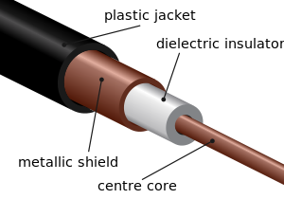

**Coaxial cables**

**TWISTED PAIR CABLES:**

**Twisted pair** eventually emerged during the 1990s as the leading cabling standard for [Ethernet](https://www.lifewire.com/definition-of-ethernet-816312), starting with 10 Mbps (**10BASE-T**, also known as Category 3 or **Cat3**), later followed by improved versions for 100 Mbps (100BASE-TX, **Cat5** and **Cat5e**) and successively higher speeds up to 10 Gbps (10GBASE-T). Ethernet twisted pair cables contain up to eight (8) wires wound together in pairs to minimize electromagnetic interference.

Two primary types of twisted pair cable industry standards have been defined: **Unshielded Twisted Pair (UTP)** and **Shielded Twisted Pair (STP)**.

Modern Ethernet cables use UTP wiring due to its lower cost, while STP cabling can be found in some other types of networks such as Fiber Distributed Data Interface (FDDI).

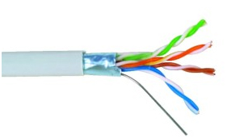

TWISTED PAIR CABLES

**FIBRE OPTICS:**

Instead of insulated metal wires transmitting electrical signals, [fiber optic network cables](http://compnetworking.about.com/od/networkcables/g/fiberopticcable.htm) work using strands of glass and pulses of light.

These network cables are bendable despite being made of glass. They have proven especially useful in [wide area network (WAN)](https://www.lifewire.com/wide-area-network-816383) installations where long distance underground or outdoor cable runs are required and also in office buildings where a high volume of communication traffic is common.

Two primary types of fiber optic cable industry standards are defined – **single-mode** (100BaseBX standard) and **multimode** (100BaseSX standard). Long-distance telecommunications networks more commonly use single-mode for its relatively higher [bandwidth](https://www.lifewire.com/what-is-bandwidth-p2-818121) capacity, while local networks typically use multimode instead due to its lower cost.

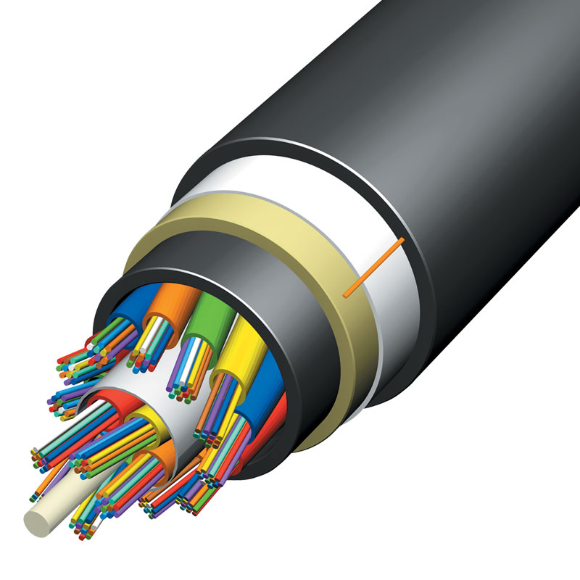

FIBRE OPTICS

**USB CABLES:**

Most [Universal Serial Bus (USB)](https://www.lifewire.com/universal-serial-bus-816265) cables connect a computer with a peripheral device (keyboard or mouse) rather than to another computer. However, special [network adapters](https://www.lifewire.com/definition-of-adapter-817585) (sometimes called [dongles](https://www.lifewire.com/definition-of-dongle-816315)) also allow connecting an Ethernet cable to a [USB port](https://www.lifewire.com/what-is-a-usb-port-818166) indirectly. USB cables feature twisted-pair wiring.

**SERIAL AND PARALLEL CABLES:**

Because many PCs in the 1980s and early 1990s lacked Ethernet capability, and USB had not been developed yet, serial and parallel interfaces (now obsolete on modern computers) were sometimes used for PC-to-PC networking. So-called [null model cables](https://www.lifewire.com/buying-cable-modem-for-broadband-internet-817448), for example, connected the [serial ports](https://www.lifewire.com/definition-of-a-serial-port-817862) of two PCs enabling data transfers at speeds between 0.115 and 0.45 Mbps

**STRAIGHT THROUGH CABLE CONNECTION:**

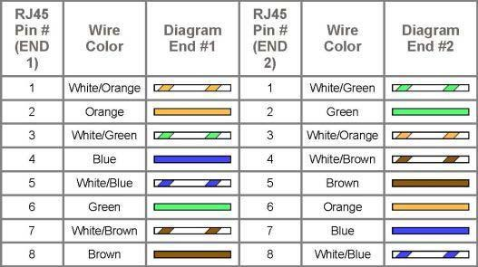

**CROSSOVER CABLE CONNECTION:**

